

Java III Project – Product Specification Document

THIS is the product specification document for the java project

Ke Swen Lee | Java III | 26/11/2020

Version History

|  |  |  |  |  |  |
| --- | --- | --- | --- | --- | --- |
| Version | Implemented By | Revision Date | Approval By | Approval Date | Reason |
| 1.0 | Swen Lee | 13/11/2020 | Ken Beck | 20/11/2020 | Initial Project Proposal Document |
| 1.1 | Swen Lee | 13/11/2020 | Ken Beck | 20/11/2020 | Organisational Information |
| 1.2 | Swen Lee | 16/11/2020 | Ken Beck | 20/11/2020 | Requirements Report (Functional and Non-functional) |
| 1.3 | Swen Lee | 17/11/2020 | Ken Beck | 20/11/2020 | Feasibility Report |
| 1.4 | Swen Lee | 18/11/2020 | Ken Beck | 20/11/2020 | Software Solution |
| 1.5 | Swen Lee | 19/11/2020 | Ken Beck | 20/11/2020 | Risk Analysis |

Table of Contents

Introduction 1

Architecture Design 2

Logical View 2

Hardware Architecture 2

Software Architecture 2

Communication Architecture 2

System Design 3

Use Cases 3

User Interface Design 4

Server 4

Client 4

Product Specification Design Approval 5

# Introduction

Describes the purpose of a product specification design document.

The Product Specification Design document documents and tracks the necessary information required to effectively define architecture and system design in order to give the development team guidance on architecture of the system to be developed. The Product Specification Design document is created during the Planning Phase of the project. Its intended audience is the project manager, project team, and development team. Some portions of this document such as the user interface (UI) may on occasion be shared with the client/user, and other stakeholder whose input/approval into the UI is needed.

# Architecture Design

This section outlines the system and hardware architecture design of the system that is being built.

## Logical View

As the project was developed using Java, it is portable and able to be used on all devices.

## Hardware Architecture

1. Desktop or laptop computer
2. Random Access Memory (RAM): 2GB

## Software Architecture

1. Operating System: Windows 10

## Communication Architecture

The communication platform used is [Trello](https://trello.com/en).

# System Design

## Use Cases

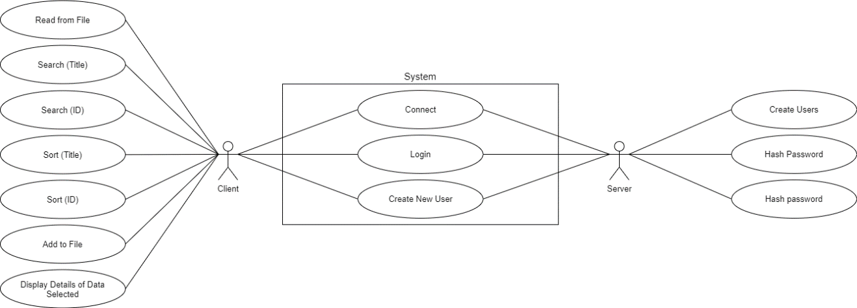

## User Interface Design

### Server

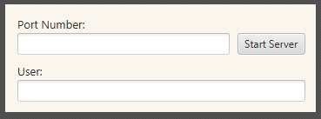

### Client

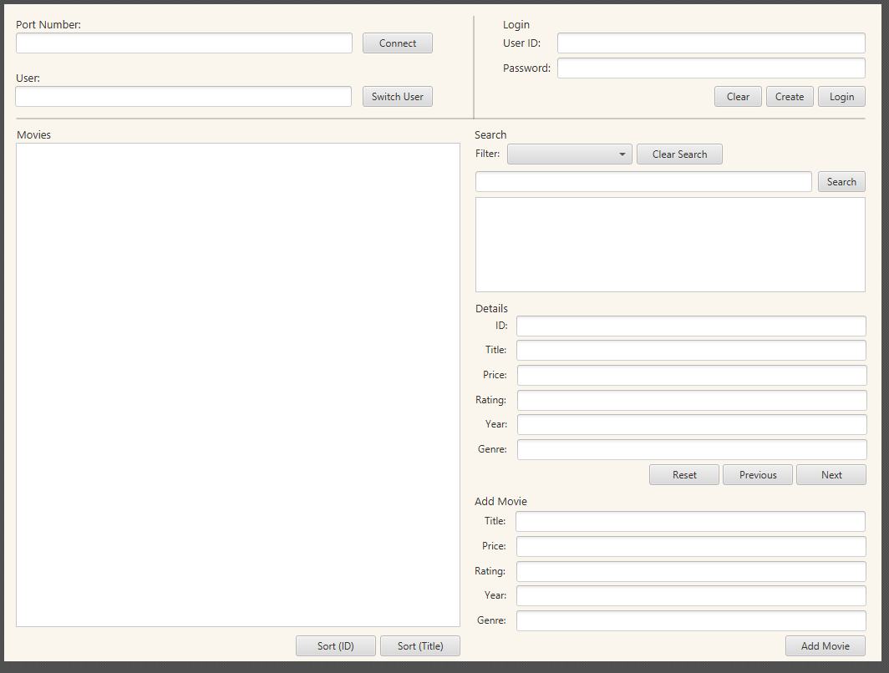

# Product Specification Design Approval

The undersigned acknowledge they have reviewed the Movie Database Project **Product Specification Design** document and agree with the approach it presents. Any changes to this Requirements Definition will be coordinated with and approved by the undersigned or their designated representatives.

Signature:

Print Name: Ken Beck

Title: Project Manager (Lecturer)

Role: Project Approval

Date: